Binomial Expansion- Questions
June 2019 Mathematics Advanced Paper 1: Pure Mathematics 1

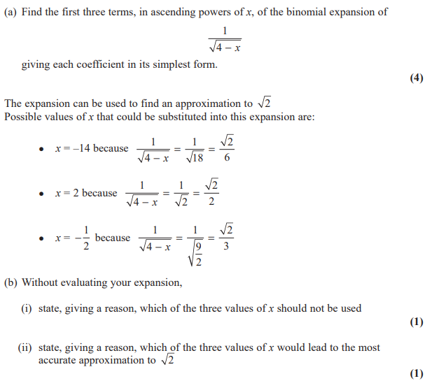

June 2018 Mathematics Advanced Paper 1: Pure Mathematics 1

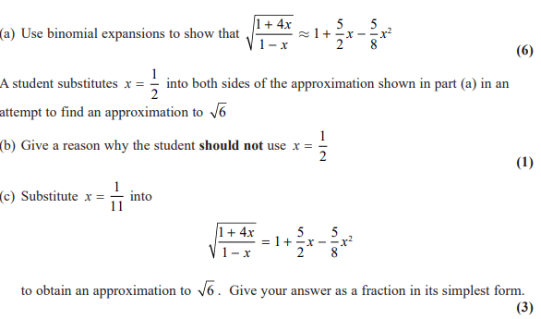

May 2019 Mathematics Advanced Paper 1: Pure Mathematics 1

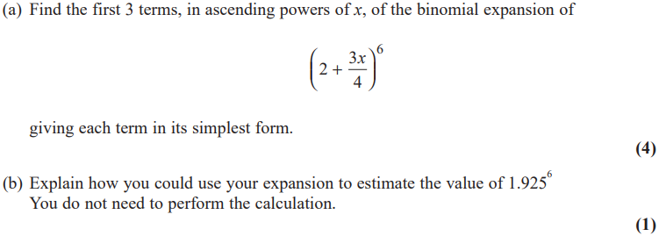

May 2018 Mathematics Advanced Paper 1: Pure Mathematics 1

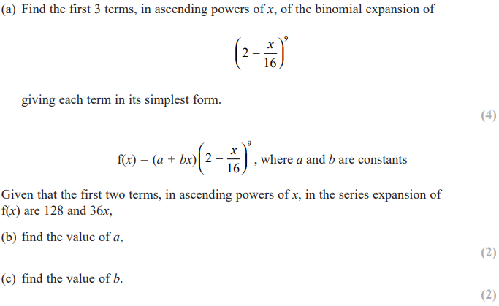

May 2017 Mathematics Advanced Paper 1: Pure Mathematics 2

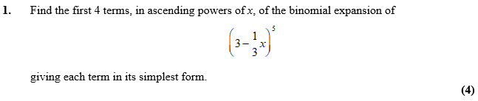
May 2015 Mathematics Advanced Paper 1: Pure Mathematics 2

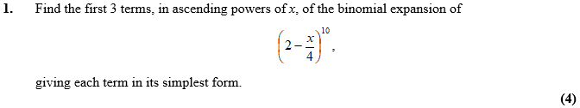
Jan 2013 Mathematics Advanced Paper 1: Pure Mathematics 2

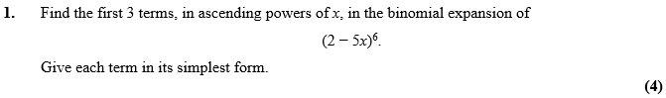

May 2012 Mathematics Advanced Paper 1: Pure Mathematics 2

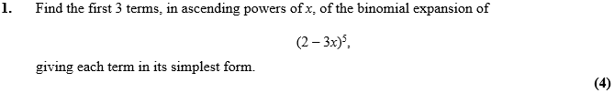

Jan 2010 Mathematics Advanced Paper 1: Pure Mathematics 2

